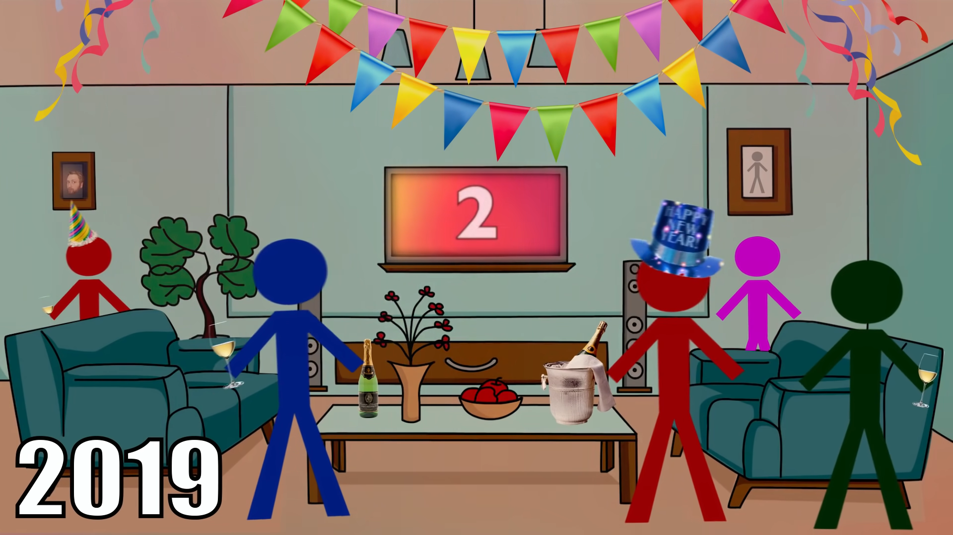

Javier invited all his work friends to his New Year's Eve party. Javier is the one with the blue hat. He is so happy, the next year he has so many things to do, he will ask his girlfriend to marry him, look for a job with better benefits and even already bought a full year membership in a gym. If his vision of life has started to change, making him more confident, he knows that nothing can go wrong. He looks forward to 2020 with open arms and a smile on his face. Poor Javier.

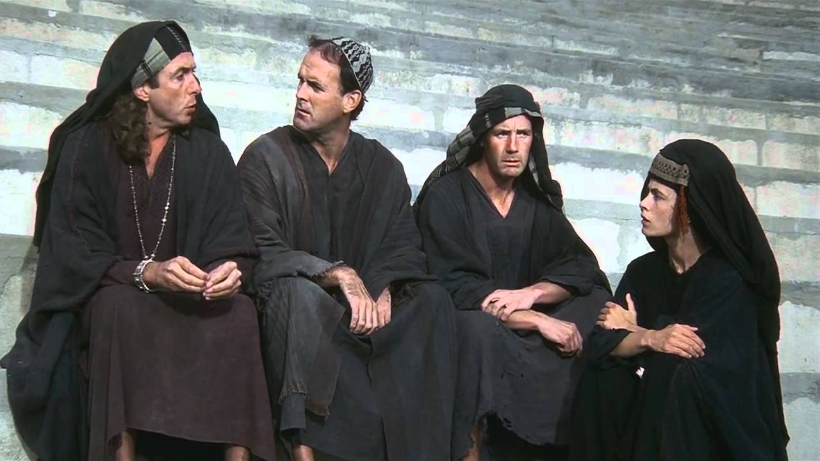

Andino has just received bad news, his father has passed away and the entire inheritance has been left to his younger brother, his friends are confused because all his life they had thought that Andino was an orphan because they had never seen him with his father. To which he replies that he was always in the war fighting and also that that is why he died. He does not know what to do because his brother is barely 15 years old and he plans to spend it all on garbage. Andino is very angry and plans to steal everything from his brother. In a few moments he will ask his friends for help.

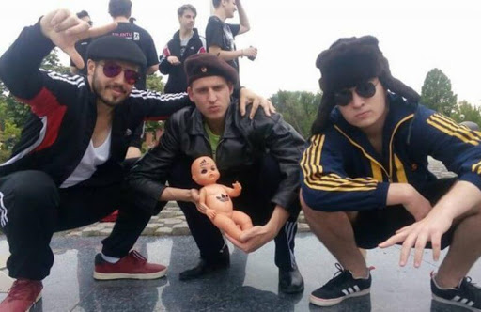

Vilen is celebrating with his gang brothers, he has just received the news that his girlfriend is pregnant. So he decides to take a photo to commemorate the moment for the rest of his life. Life is good, Vilen thinks. He looks forward to the day when he can lift his baby into his arms and teach him everything he knows about life.